**Schedule Databricks Notebook Using JobCluster Through ADF**

#### **Project Overview**

The objective of this project is to automate the execution of a Databricks notebook using a job cluster through Azure Data Factory (ADF). The workflow involves the movement and processing of data between multiple storage accounts and containers, with a focus on data cleaning, transformation, and error handling.

### **Workflow Steps**

1. **Storage Account Utilization**
   * Utilized two Azure Storage Accounts for data operations:
     + **Source Storage Account:** Data is copied from the source container.
     + **Destination Storage Account:** Processed data is stored here in designated containers.
2. **Data Pipeline Stages**
   * **On Premise Container:** Incoming raw data is transferred to this container.
   * **Raw Container:** Data cleaning and transformation tasks are performed here.
   * **Processed Container:** Finalized and validated data is stored.
   * **Staging Container:** Required data is copied for further analysis and operations.

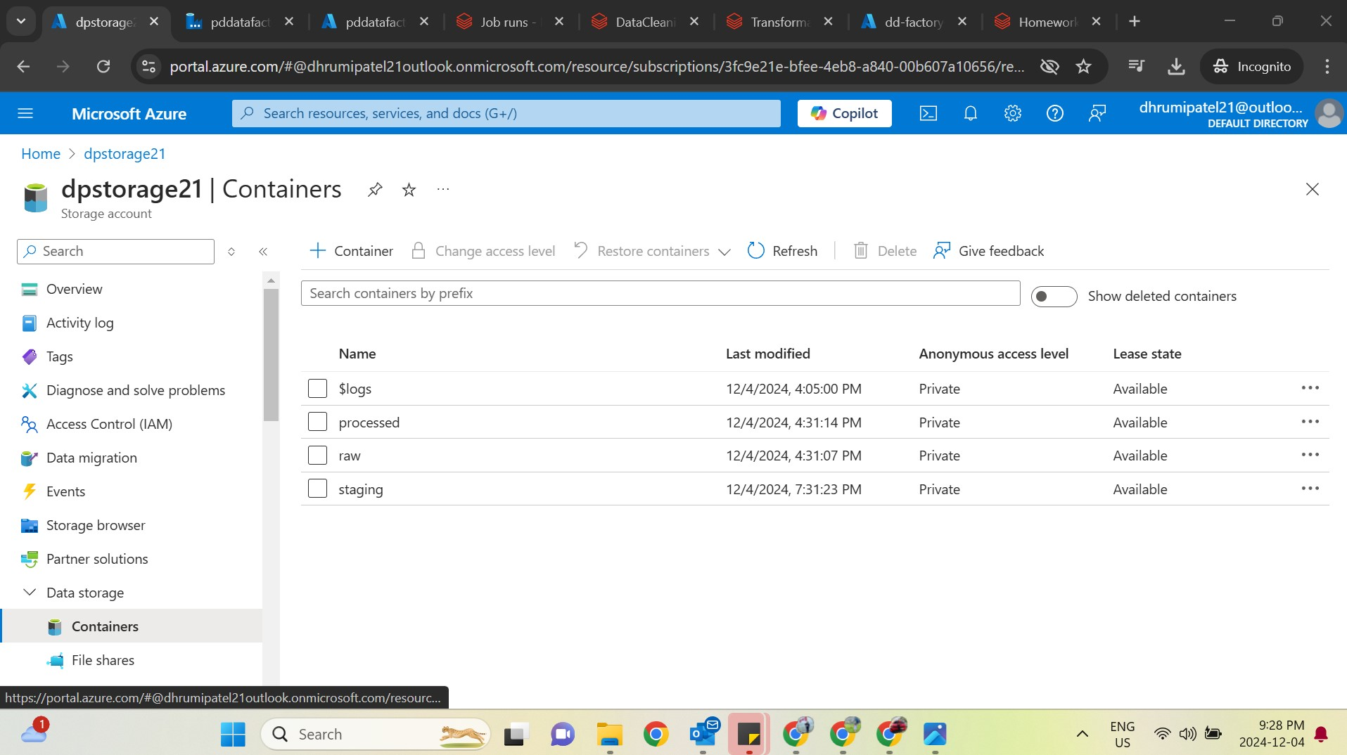

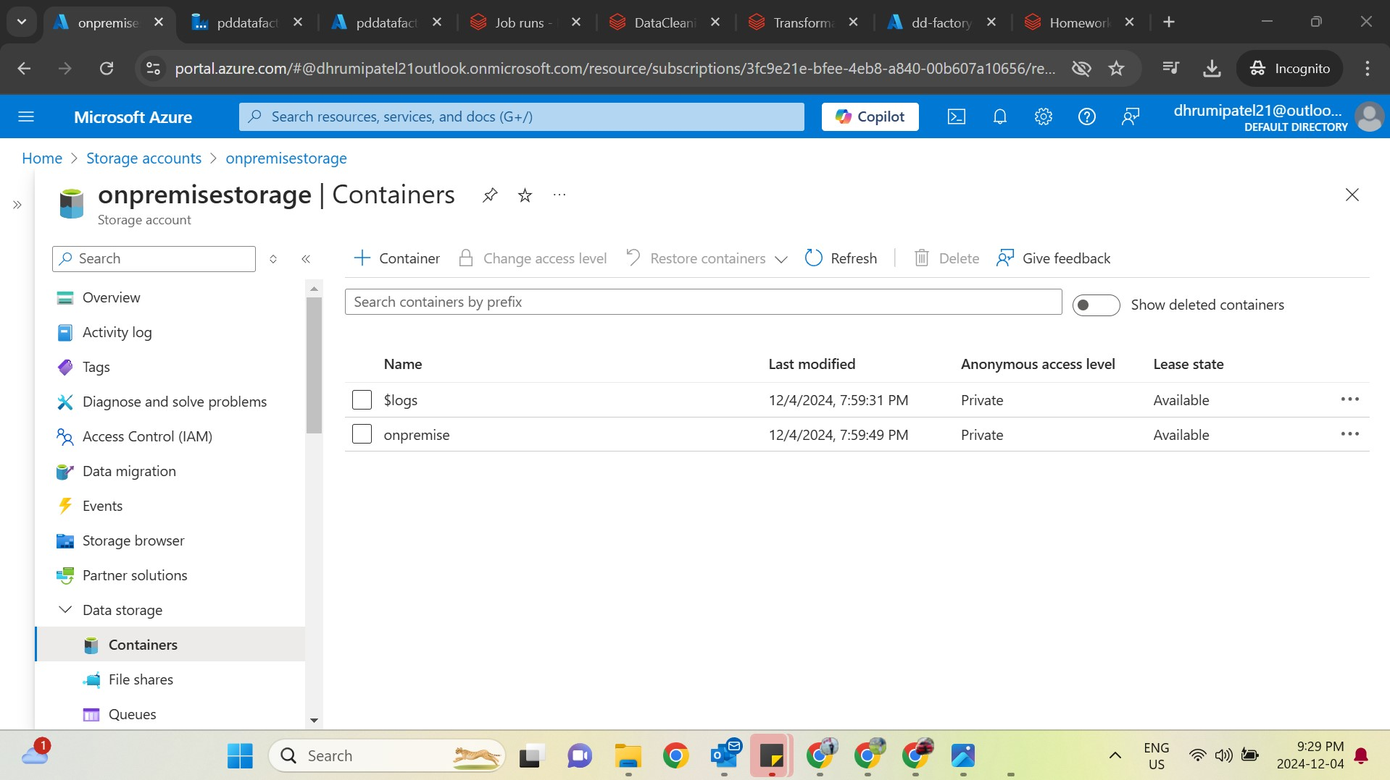

1. **Dynamic Parameterization**
   * Implemented dynamic parameters in Azure Data Factory to enhance the flexibility and scalability of the pipelines.
2. **Data Transformation**
   * **Python Scripting:**
     + Performed data cleaning using Python scripts.
     + Implemented mounting and unmounting of storage containers in Databricks for efficient data access.
   * Data was transformed and organized into the required format.
3. **Version Control & Error Logging**
   * Ensured version control of scripts and notebooks using Databricks Git integration.
   * Error logs were implemented at each stage of the pipeline to track and troubleshoot issues efficiently.

### 

### **Technical Components**

1. **Azure Data Factory (ADF)**
   * Pipeline created for dynamic data movement between storage accounts and containers.
   * Parameters were utilized to dynamically control the file paths and dataset configurations.
2. **Databricks**
   * A Databricks job cluster was scheduled through ADF for running the notebook.
   * Notebook Tasks:
     + Data Mounting
     + Cleaning and Transformation
     + Data Writing to Containers
3. **Key Vault Integration**
   * Integrated Azure Key Vault to securely manage sensitive information such as tokens and credentials.
   * 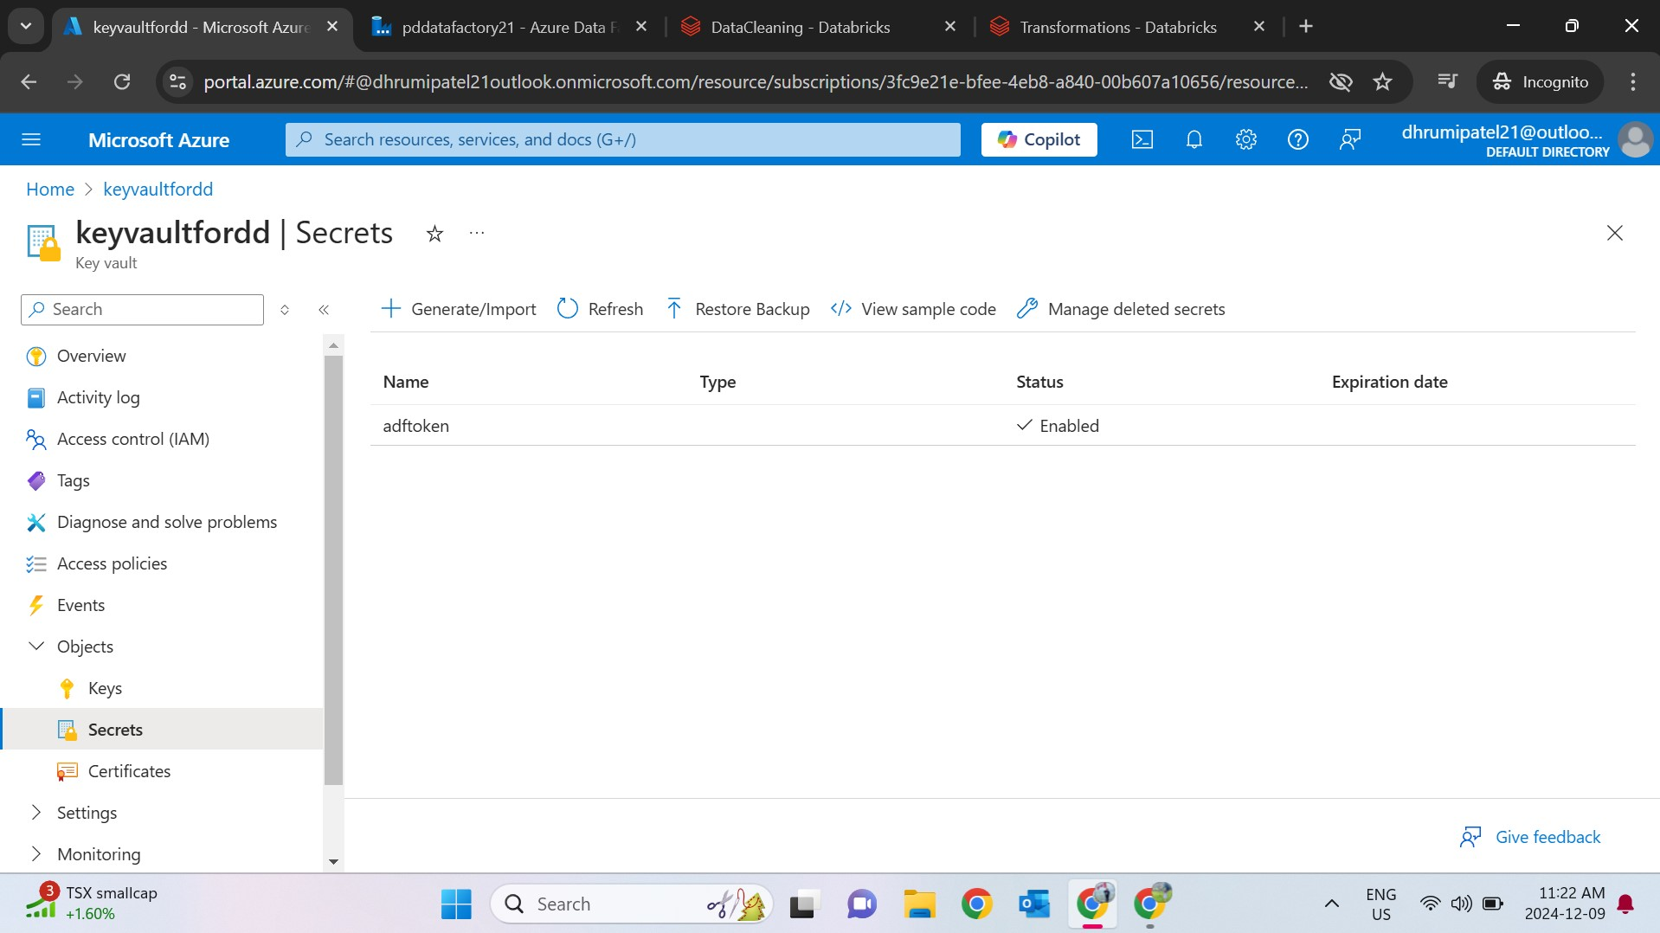

### **Outputs**

* Cleaned and transformed datasets in the final stage container.
* Consolidated data moved to the staging container for further utilization.

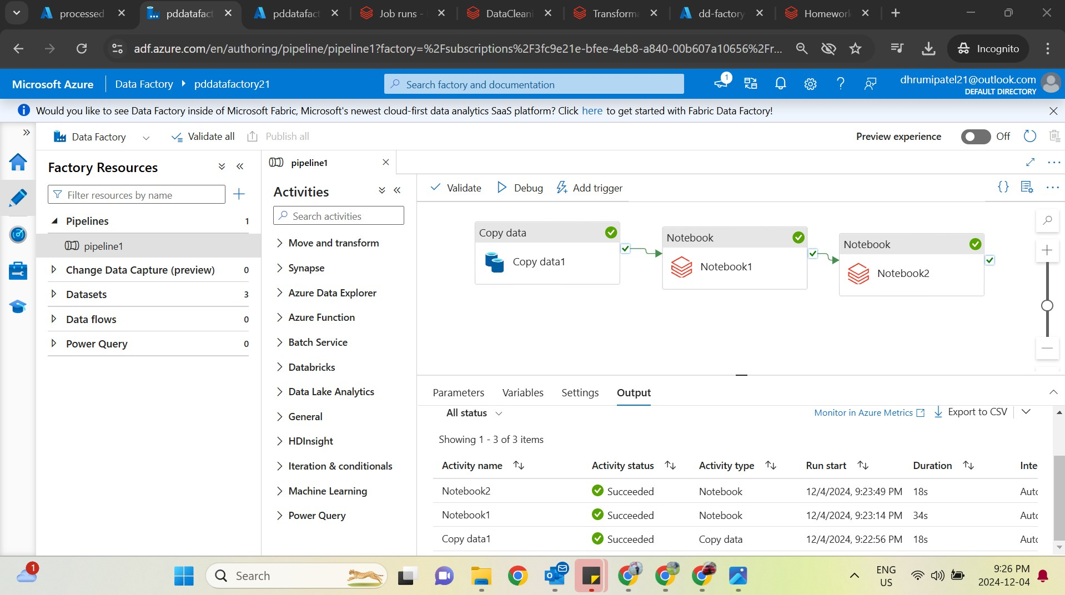

### **Error Handling**

* Configured pipelines to log errors during each phase of execution.
* Implemented retry mechanisms in ADF for transient failures.

### **Supporting Files**

* **HTML Output:** Data cleaning result files (DataCleaning_outputfile.html).
* **JSON Configuration:** Pipeline definition for ADF ([Json file for pipeline.txt](mnt/data/Json file for pipeline.txt)).
* **Notebook:** Transformations and Mounting tasks (TransformationswithMounting.ipynb).

### 

### **Conclusion**

This project successfully demonstrates the end-to-end automation of data processing using Azure Data Factory and Databricks, incorporating dynamic parameters, secure token management, and error logging mechanisms.